**AIM: Demonstrate use of explicit and implicit intents.**

**OUTPUT:**

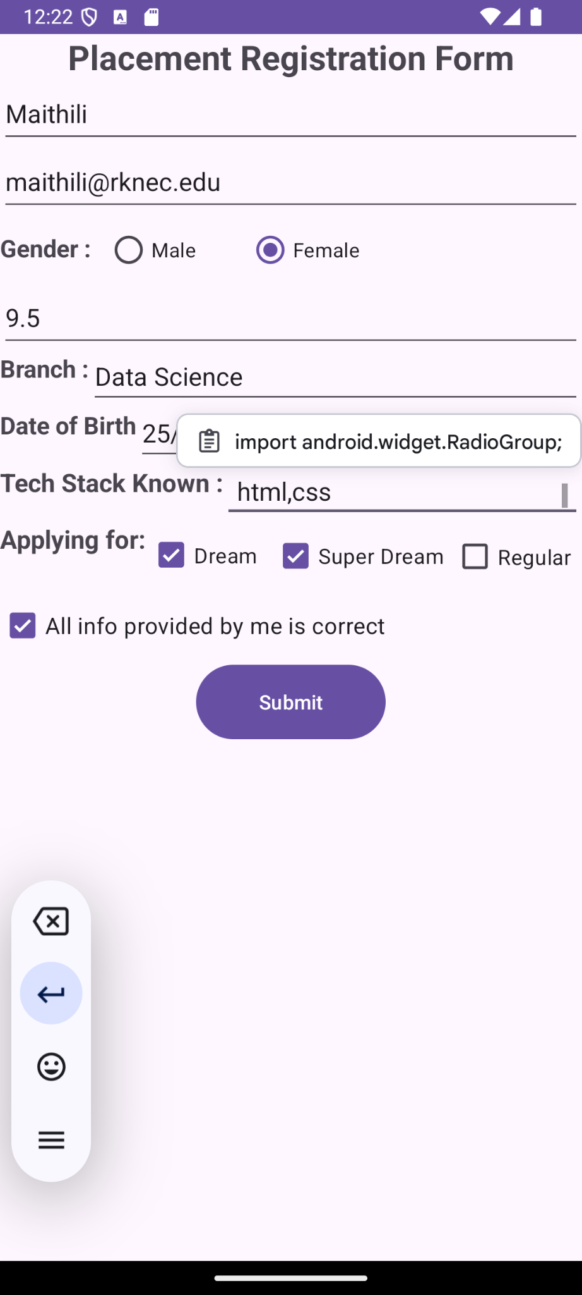

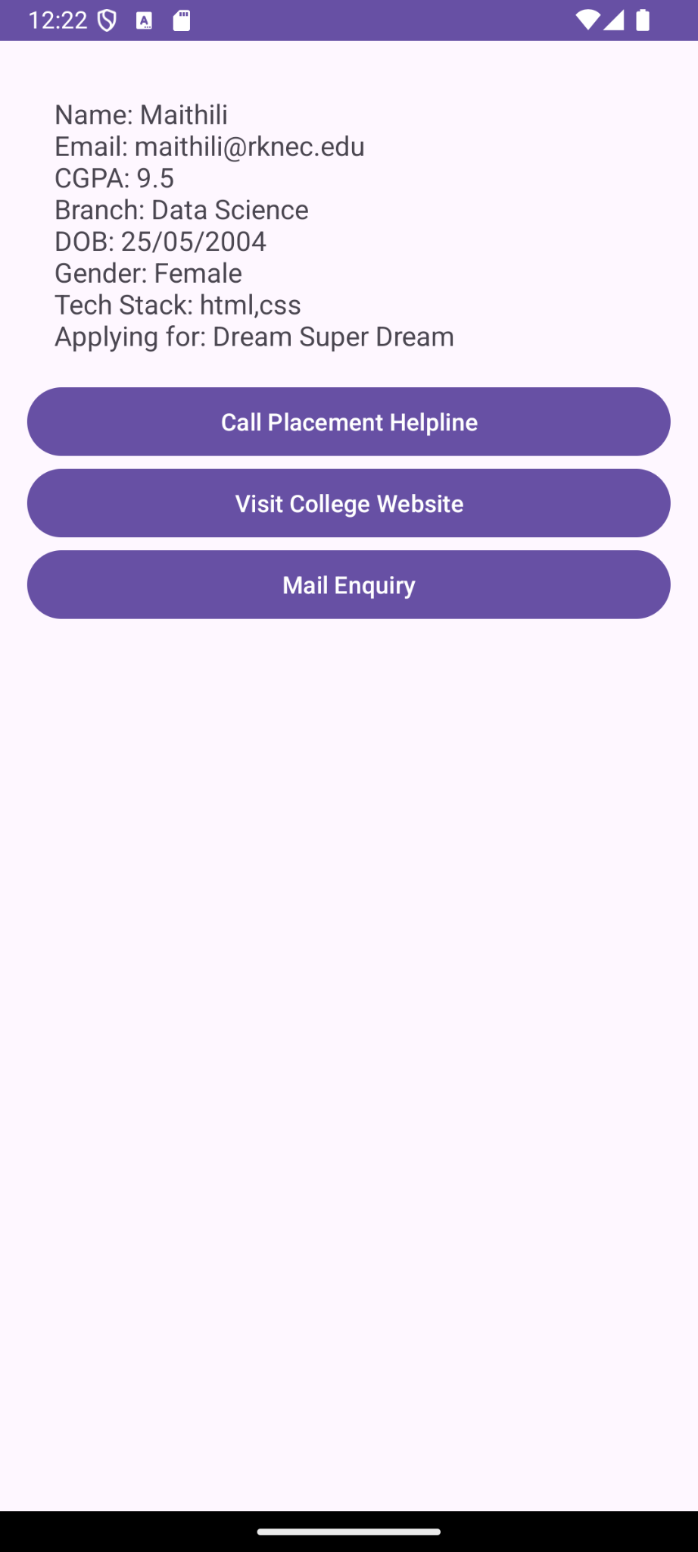

**MainActivity.xml**

<?xml version="1.0" encoding="utf-8"?>

<androidx.constraintlayout.widget.ConstraintLayout xmlns:android="http://schemas.android.com/apk/res/android"

xmlns:app="http://schemas.android.com/apk/res-auto"

xmlns:tools="http://schemas.android.com/tools"

android:id="@+id/main"

android:layout_width="match_parent"

android:layout_height="match_parent">

<TextView

android:id="@+id/titleTextView"

android:layout_width="0dp"

android:layout_height="wrap_content"

android:text="Placement Registration Form"

android:textSize="24sp"

android:textStyle="bold"

android:textAlignment="center"

app:layout_constraintEnd_toEndOf="parent"

app:layout_constraintStart_toStartOf="parent"

app:layout_constraintTop_toTopOf="parent" />

<EditText

android:id="@+id/nameEditText"

android:layout_width="0dp"

android:layout_height="wrap_content"

android:hint="Name"

android:minHeight="48dp"

android:inputType="textPersonName"

android:contentDescription="Enter your name"

app:layout_constraintEnd_toEndOf="parent"

app:layout_constraintStart_toStartOf="parent"

app:layout_constraintTop_toBottomOf="@id/titleTextView" />

<EditText

android:id="@+id/emailEditText"

android:layout_width="0dp"

android:layout_height="wrap_content"

android:hint="Email"

android:minHeight="48dp"

android:inputType="textEmailAddress"

android:contentDescription="Enter your email address"

app:layout_constraintEnd_toEndOf="parent"

app:layout_constraintStart_toStartOf="parent"

app:layout_constraintTop_toBottomOf="@id/nameEditText" />

<RadioGroup

android:id="@+id/genderRadioGroup"

android:layout_width="0dp"

android:layout_height="wrap_content"

android:orientation="horizontal"

android:minHeight="48dp"

app:layout_constraintEnd_toEndOf="parent"

app:layout_constraintStart_toStartOf="parent"

app:layout_constraintTop_toBottomOf="@id/emailEditText">

<TextView

android:layout_width="75dp"

android:layout_height="wrap_content"

android:text="Gender :"

android:textSize="17sp"

android:textStyle="bold" />

<RadioButton

android:layout_width="100dp"

android:layout_height="wrap_content"

android:text="Male"

android:minHeight="48dp" />

<RadioButton

android:layout_width="100dp"

android:layout_height="wrap_content"

android:text="Female"

android:minHeight="48dp" />

</RadioGroup>

<EditText

android:id="@+id/cgpaEditText"

android:layout_width="0dp"

android:layout_height="wrap_content"

android:hint="CGPA"

android:inputType="numberDecimal"

android:minHeight="48dp"

android:contentDescription="Enter your CGPA"

app:layout_constraintEnd_toEndOf="parent"

app:layout_constraintStart_toStartOf="parent"

app:layout_constraintTop_toBottomOf="@id/genderRadioGroup" />

<TextView

android:id="@+id/branchTextView"

android:layout_width="wrap_content"

android:layout_height="40dp"

android:text="Branch :"

android:textSize="17sp"

android:textStyle="bold"

app:layout_constraintStart_toStartOf="parent"

app:layout_constraintTop_toBottomOf="@id/cgpaEditText" />

<EditText

android:id="@+id/branchEditText"

android:layout_width="0dp"

android:layout_height="40dp"

android:minHeight="48dp"

android:hint="Branch"

android:contentDescription="Enter your branch"

app:layout_constraintEnd_toEndOf="parent"

app:layout_constraintStart_toEndOf="@id/branchTextView"

app:layout_constraintTop_toBottomOf="@id/cgpaEditText" />

<TextView

android:id="@+id/dobTextView"

android:layout_width="wrap_content"

android:layout_height="40dp"

android:text="Date of Birth"

android:textSize="17sp"

android:textStyle="bold"

app:layout_constraintStart_toStartOf="parent"

app:layout_constraintTop_toBottomOf="@id/branchEditText" />

<EditText

android:id="@+id/dobEditText"

android:layout_width="0dp"

android:layout_height="40dp"

android:inputType="date"

android:minHeight="48dp"

android:contentDescription="Enter your date of birth"

app:layout_constraintEnd_toEndOf="parent"

app:layout_constraintStart_toEndOf="@id/dobTextView"

app:layout_constraintTop_toBottomOf="@id/branchEditText" />

<TextView

android:id="@+id/techStackTextView"

android:layout_width="wrap_content"

android:layout_height="40dp"

android:text="Tech Stack Known :"

android:textSize="18sp"

android:textStyle="bold"

app:layout_constraintStart_toStartOf="parent"

app:layout_constraintTop_toBottomOf="@id/dobEditText" />

<EditText

android:id="@+id/techStackEditText"

android:layout_width="0dp"

android:layout_height="40dp"

android:gravity="top|start"

android:inputType="textMultiLine"

android:lines="5"

android:minLines="3"

android:minHeight="48dp"

android:hint="Tech Stack"

android:contentDescription="Enter the technologies you are familiar with"

android:padding="10dp"

android:scrollbars="vertical"

app:layout_constraintEnd_toEndOf="parent"

app:layout_constraintStart_toEndOf="@id/techStackTextView"

app:layout_constraintTop_toBottomOf="@id/dobEditText" />

<TextView

android:id="@+id/applyingForTextView"

android:layout_width="105dp"

android:layout_height="48dp"

android:text="Applying for: "

android:textSize="18sp"

android:textStyle="bold"

app:layout_constraintStart_toStartOf="parent"

app:layout_constraintTop_toBottomOf="@id/techStackEditText" />

<CheckBox

android:id="@+id/dreamCheckBox"

android:layout_width="88dp"

android:layout_height="47dp"

android:minHeight="48dp"

android:text="Dream"

android:textSize="15sp"

app:layout_constraintStart_toEndOf="@id/applyingForTextView"

app:layout_constraintTop_toBottomOf="@id/techStackEditText" />

<CheckBox

android:id="@+id/superDreamCheckBox"

android:layout_width="127dp"

android:layout_height="48dp"

android:minHeight="48dp"

android:text="Super Dream"

android:textSize="15sp"

app:layout_constraintStart_toEndOf="@id/dreamCheckBox"

app:layout_constraintTop_toBottomOf="@id/techStackEditText" />

<CheckBox

android:id="@+id/regularCheckBox"

android:layout_width="89dp"

android:layout_height="49dp"

android:minHeight="48dp"

android:text="Regular"

android:textSize="15sp"

app:layout_constraintStart_toEndOf="@id/superDreamCheckBox"

app:layout_constraintTop_toBottomOf="@id/techStackEditText" />

<CheckBox

android:id="@+id/allInfoCheckBox"

android:layout_width="0dp"

android:layout_height="wrap_content"

android:minHeight="48dp"

android:text="All info provided by me is correct"

android:textSize="16sp"

app:layout_constraintEnd_toEndOf="parent"

app:layout_constraintStart_toStartOf="parent"

app:layout_constraintTop_toBottomOf="@id/regularCheckBox" />

<Button

android:id="@+id/button"

android:layout_width="134dp"

android:layout_height="60dp"

android:text="Submit"

tools:layout_editor_absoluteX="158dp"

tools:layout_editor_absoluteY="474dp"

app:layout_constraintEnd_toEndOf="parent"

app:layout_constraintStart_toStartOf="parent"

app:layout_constraintTop_toBottomOf="@id/allInfoCheckBox"/>

</androidx.constraintlayout.widget.ConstraintLayout>

**activity_main.java**

package com.example.placementapp20;

import android.content.Intent;

import android.os.Bundle;

import android.view.View;

import android.widget.Button;

import android.widget.EditText;

import android.widget.RadioGroup;

import android.widget.RadioButton;

import android.widget.CheckBox;

import androidx.appcompat.app.AppCompatActivity;

public class MainActivity extends AppCompatActivity {

private EditText nameEditText, emailEditText, cgpaEditText, branchEditText, dobEditText, techStackEditText;

private CheckBox dreamCheckBox, superDreamCheckBox, regularCheckBox, allInfoCheckBox;

private RadioGroup genderRadioGroup;

private Button submitButton;

@Override

protected void onCreate(Bundle savedInstanceState) {

super.onCreate(savedInstanceState);

setContentView(R.layout.*activity_main*);

// Initialize views

nameEditText = findViewById(R.id.*nameEditText*);

emailEditText = findViewById(R.id.*emailEditText*);

cgpaEditText = findViewById(R.id.*cgpaEditText*);

branchEditText = findViewById(R.id.*branchEditText*);

dobEditText = findViewById(R.id.*dobEditText*);

techStackEditText = findViewById(R.id.*techStackEditText*);

genderRadioGroup = findViewById(R.id.*genderRadioGroup*);

dreamCheckBox = findViewById(R.id.*dreamCheckBox*);

superDreamCheckBox = findViewById(R.id.*superDreamCheckBox*);

regularCheckBox = findViewById(R.id.*regularCheckBox*);

allInfoCheckBox = findViewById(R.id.*allInfoCheckBox*);

submitButton = findViewById(R.id.*button*);

// Set click listener for SUBMIT button

submitButton.setOnClickListener(v -> {

// Collect form data

String name = nameEditText.getText().toString();

String email = emailEditText.getText().toString();

String cgpa = cgpaEditText.getText().toString();

String branch = branchEditText.getText().toString();

String dob = dobEditText.getText().toString();

String techStack = techStackEditText.getText().toString();

String gender = ((RadioButton) findViewById(genderRadioGroup.getCheckedRadioButtonId())).getText().toString();

String applyingFor = (dreamCheckBox.isChecked() ? "Dream " : "") +

(superDreamCheckBox.isChecked() ? "Super Dream " : "") +

(regularCheckBox.isChecked() ? "Regular" : "");

// Form data as string

String formData = "Name: " + name + "\nEmail: " + email + "\nCGPA: " + cgpa + "\nBranch: " + branch +

"\nDOB: " + dob + "\nGender: " + gender + "\nTech Stack: " + techStack + "\nApplying for: " + applyingFor;

// Start Activity2 using explicit intent

Intent intent = new Intent(MainActivity.this, MainActivity2.class);

intent.putExtra("formData", formData);

startActivity(intent);

});

}

}

**MainActivity2.xml**

<LinearLayout xmlns:android="http://schemas.android.com/apk/res/android"

android:layout_width="match_parent"

android:layout_height="match_parent"

android:orientation="vertical"

android:padding="16dp">

<TextView

android:id="@+id/formDataTextView"

android:layout_width="match_parent"

android:layout_height="wrap_content"

android:textSize="16sp"

android:padding="16dp" />

<Button

android:id="@+id/callButton"

android:layout_width="match_parent"

android:layout_height="wrap_content"

android:text="Call Placement Helpline" />

<Button

android:id="@+id/visitButton"

android:layout_width="match_parent"

android:layout_height="wrap_content"

android:text="Visit College Website" />

<Button

android:id="@+id/mailButton"

android:layout_width="match_parent"

android:layout_height="wrap_content"

android:text="Mail Enquiry" />

</LinearLayout>

**activity_main2.java**

package com.example.placementapp20;

import android.content.Intent;

import android.net.Uri;

import android.os.Bundle;

import android.view.View;

import android.widget.Button;

import android.widget.TextView;

import androidx.appcompat.app.AppCompatActivity;

public class MainActivity2 extends AppCompatActivity {

private TextView formDataTextView;

private Button callButton, visitButton, mailButton;

@Override

protected void onCreate(Bundle savedInstanceState) {

super.onCreate(savedInstanceState);

setContentView(R.layout.*activity_main2*);

// Get data from Intent

Intent intent = getIntent();

String formData = intent.getStringExtra("formData");

// Set form data

formDataTextView = findViewById(R.id.*formDataTextView*);

formDataTextView.setText(formData);

// Handle Call Button

callButton = findViewById(R.id.*callButton*);

callButton.setOnClickListener(v -> {

Intent dialIntent = new Intent(Intent.*ACTION_DIAL*);

dialIntent.setData(Uri.*parse*("tel:1234567890")); // Replace with actual helpline number

startActivity(dialIntent);

});

// Handle Visit Button

visitButton = findViewById(R.id.*visitButton*);

visitButton.setOnClickListener(v -> {

Intent browserIntent = new Intent(Intent.*ACTION_VIEW*, Uri.*parse*("http://www.rknec.edu"));

startActivity(browserIntent);

});

// Handle Mail Button

mailButton = findViewById(R.id.*mailButton*);

mailButton.setOnClickListener(v -> {

Intent emailIntent = new Intent(Intent.*ACTION_SENDTO*, Uri.*parse*("mailto:enquiry@rknec.edu"));

emailIntent.putExtra(Intent.*EXTRA_SUBJECT*, "Placement Enquiry");

startActivity(Intent.*createChooser*(emailIntent, "Send email..."));

});

}

}

**CONCLUSION :**

In this practical application, we've created a user-friendly Android app that allows users to fill out a placement registration form. Upon clicking the "SUBMIT" button, the app seamlessly transitions to a second activity that displays all the submitted details. Additionally, users can interact with buttons to dial a placement helpline, visit the college website, or send an email inquiry, showcasing the use of both explicit and implicit intents. This project not only enhances our understanding of Android development concepts but also illustrates how to build a functional and engaging user experience.